ECE 424

Team Design #1: ALU Bitslice

This is a team assignment. You should work with a partner. You need turn in only one assignment for the pair of students. This policy will be the same for all VHDL assignments and PCB assignments. However, all homework assignments are still individual.

Your task for the first part of this assignment is to simulate the “bit slice” found in the Appendix:

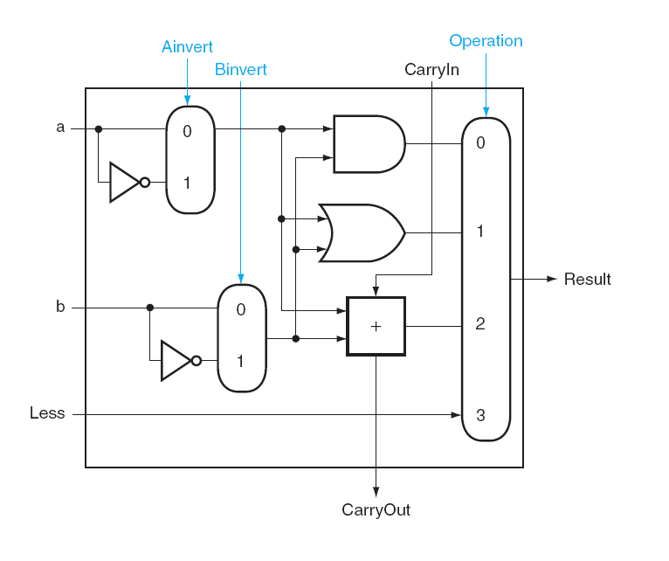

We will be using the PC version of ModelSim to complete this assignment.

ModelSim Preview

Start up ModelSim by going to the start menu, then selecting “ModelSim SE”. If you are asked to enter in a license server, use

1717@ruby

As the license server.

When ModelSim starts, create a new Project:
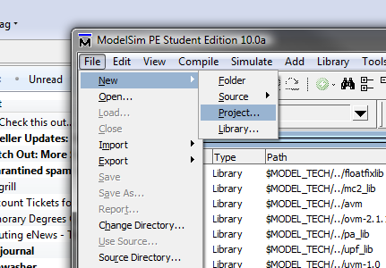

Then add a new file to the project called bit_slice.vhd

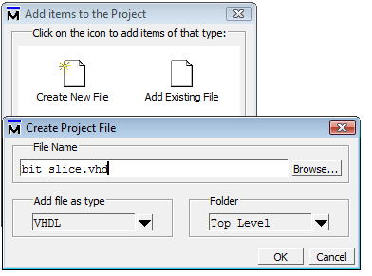

To get you started, you may wish to copy over the template file posted on the web page, template.vhd .

Making the Bit Slice (basic)

Your PORT mapping should have the following inputs:

a in std_logic
b in std_logic
Less in std_logic
Ainvert in std_logic
carryIn in std_logic
Op in std_logic_vector (2 downto 0)
(the Op signal is both the signal for the MUX and the Binvert line – three bits)

and the following outputs:
result out std_logic
carryout out std_logic

Use the figure on the first page of this handout to create the logic for the bit slice.

To compile your project, you can compile individual files, or compile all of the project:
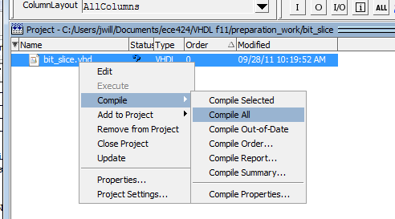

If you get an error, you can double-click on the error to show you where you have a problem:
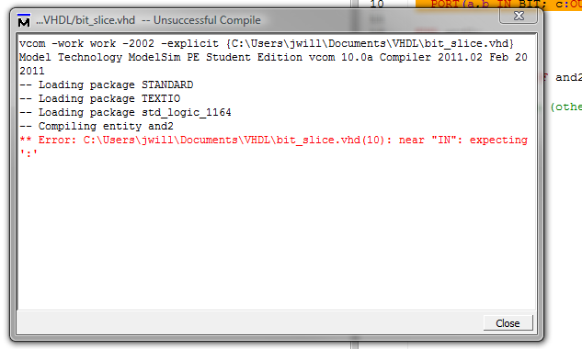

Simulating
Start simulation for your design:
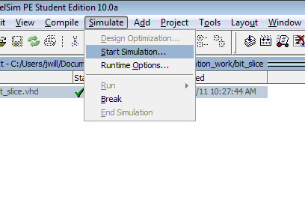
Select your design, then click OK.
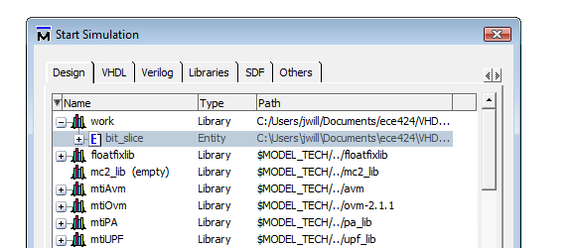

Then, make sure to add signals:
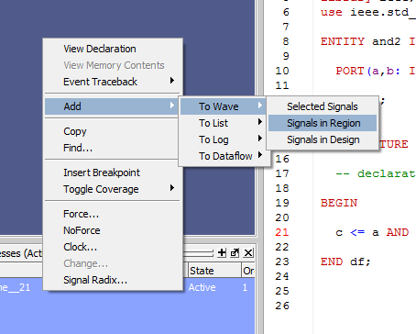

(This will add all of your signals. If you don’t want them all, you can delete the ones you don’t want from the Wave window.)

The easiest way to simulate your design is to use a force file. There is a sample force file in the web page directory. This will input all possible values for a, b, and CarryIn, but for fixed values of Less and Op. MODIFY the .do file for the needs of this assignment. It is just an example.

After you have loaded the signals in the Wave directory, run the force file (unmodified for now) by typing “do bit_slice.do” in the Transcript window:

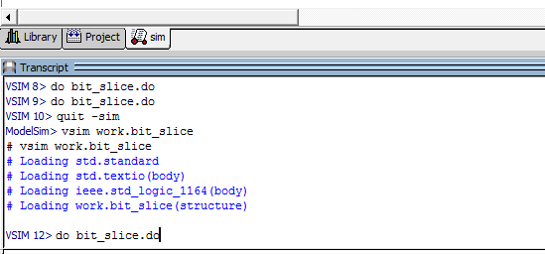

You will then see the waveforms in the Wave Window:

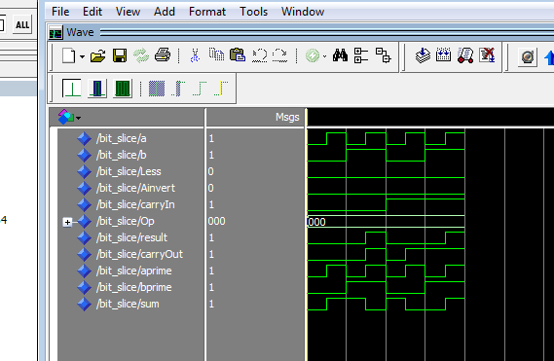

You will need to run the simulation several times, changing Less and Op to the following values, then running the simulation. Do the following in order:

Op | Less
AND | 0 | (unmodified file, this first test)
AND | 1 | (you have to modify file for this
OR | 0 | And following…)
OR | 1
ADD | 0
ADD | 1
SUB | 0
SUB | 1
SLT | 0
SLT | 1

Produce five graphs total, one for each function, with Less 0, then 1 for each. Print out each graph on a separate page and include it in your packet to turn in. (You may wish to “restart simulation” at the beginning of each new function to give you a fresh graph.):

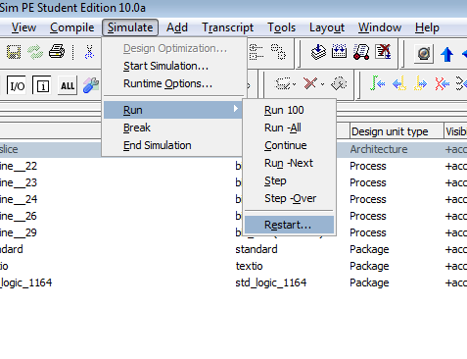

Part 2

Create a new .vhd file called MSB_slice.vhd that implements the additional hardware and ouputs needed for the following schematic:
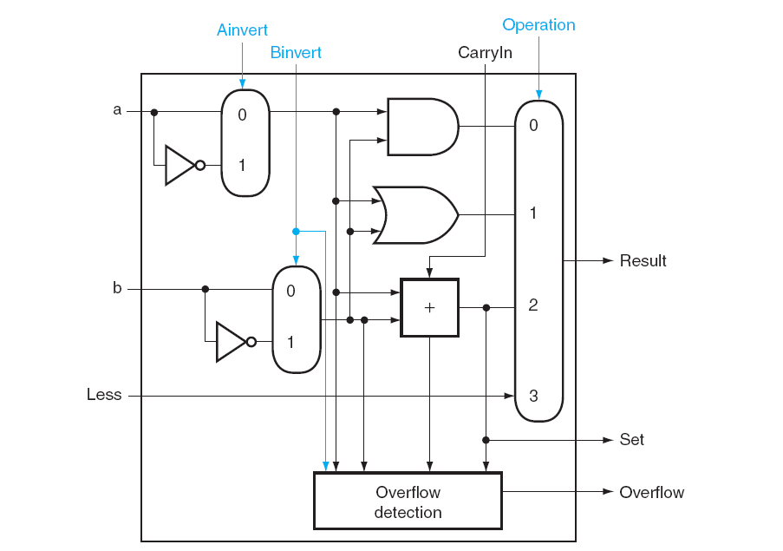

Use the same PORT map, just add two more std_logic_vector outputs, set first, then overflow. Note: overflow can be calculated much easier than the complex box shown in the schematic.

Using the same simulation process, generate the five graphs you did in part 1, but include the two new outputs (set, overflow) in the wave window.

Honor Code Issues: Each of you should contribute in part to this assignment. Examples would include one student working on a low-level device (such as a full-adder) which would then be incorporated into a larger design by the other team member. You do not have to work on all parts of the project, but there should be equal contribution from both members of the team. Also, the non-tolerance clause of the Honor Code requires you to report such “hitchhikers” from just signing their name on this assignment.
ECE 424
DUE: Oct 19 in class

Team Design #1: ALU Bitslice (50 pts)

COVER SHEET

Honor Code: ________________________________________________________________

___________________________________________________________________________

Name:_____________________________________ Signature: ________________________

Honor Code: ________________________________________________________________

___________________________________________________________________________

Name:_____________________________________ Signature: ________________________

Include:
0) This coverpage stapled on the front
1) Your VHDL code for part 1
2) Your waveform results for part 1: 5 pages, one for each function
3) Your VHDL code for part 2
4) Your waveform results for part 2: 5 pages, one for each function

